Sarah Wessel

Raymond You

EECE Lab 7

Assignment 1

When the switch is on 0, the scope component just displays a straight line down the middle (0) or x-axis. When the switch is on 1, the scope displays the cycle which counts up to 250 then resets. 0 is off, 1 is on.

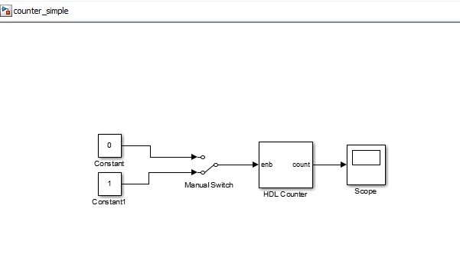

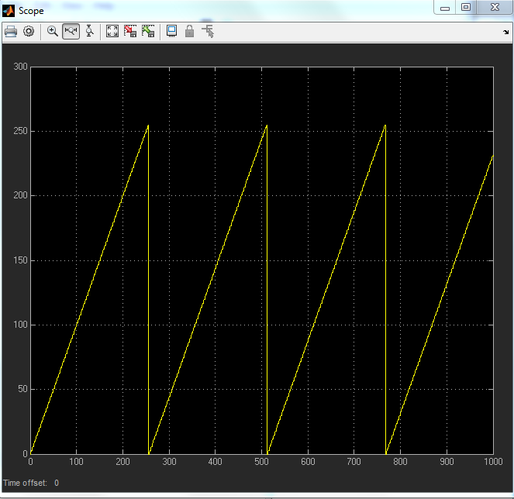

Assignment 2

We observe that the scope spikes from 0 to 1 at x=25 and repeats the spike with a period of 250. This happens because our HDL counter counts to 250 by increments of 1 and resets when it reaches 250. The counter feeds into a compare to constant block which only outputs 1 when the HDL counter gives it 25. This leads to the periodic output of 1 in our scope.

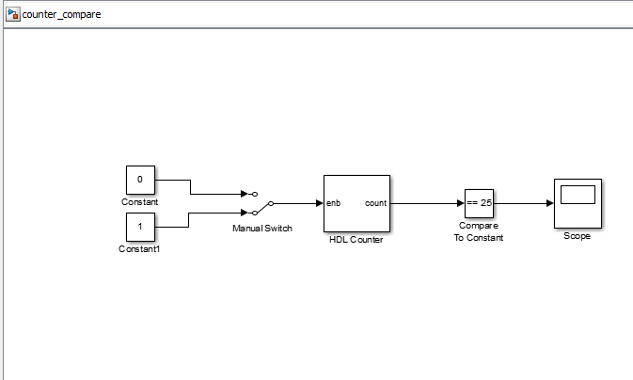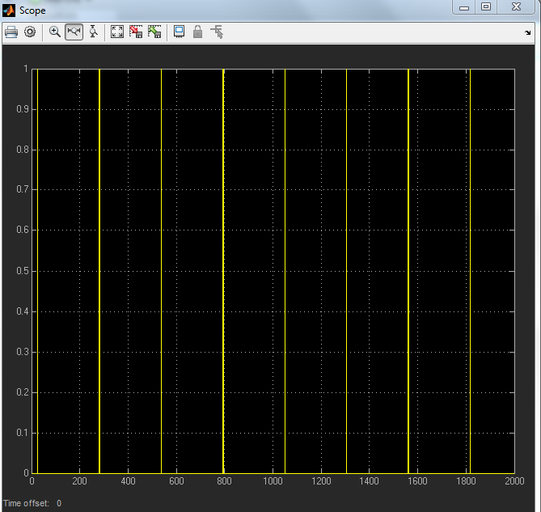

Assignment 3

Scope1 has the same output as it did in assignment 1. It steps to the next value every cycle and returns to 0 when it hits 250. Scope is similar to scope 1 but takes its first step after 25 cycles and takes another step every 250 cycles after that.

To change the counting speed of the second counter, we could change the reset value of the first counter. Alternatively, if needed to keep the first counter as it is, we could create a new counter with a different reset value and feed it in to the same or different compare to constant block.

Assignment 4

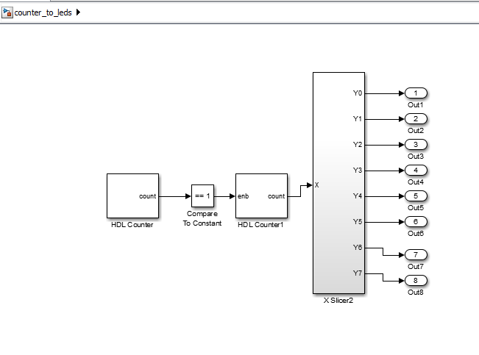

10a) 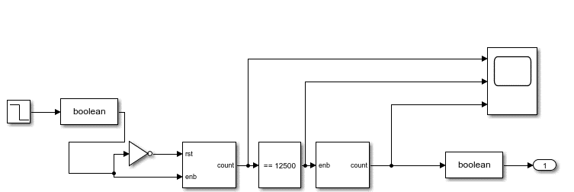

10b)

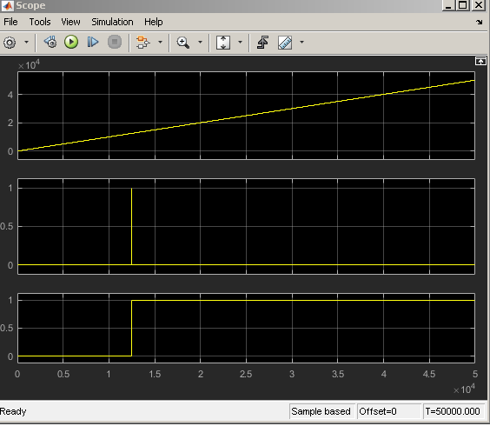

Assignment 5

